Software Deployment AT1.1

30003389 – Kyer Potts

Table of Contents

Table of Contents i

Software Development Methodologies Comparisons 1

Waterfall Method 1

Agile Method 1

Prototype Method 2

Rapid Application Development 2

Dynamic Systems Development Methodology 3

Project Management Program 4

ProjectLibre 4

Key Features 4

ProjectLibre Demonstration 4

Source Control System 8

GitHub 8

GitHub Features 8

Collaboration Software 9

Trello 9

Trello Features 9

References 10

# Software Development Methodologies Comparisons

### Waterfall Method

The waterfall method is the most commonly used software development methodology. It uses a linear structure timeline to move through steps of project completion until the software is ready for handover or deployment. The next step or phase in the project timeline only begins once the previous step has finished.

#### Advantages

* The simple layout of the lifecycle is very easy to understand.
* The static nature of the model makes it easy to manage and plan.
* Is a very capable model for dealing with project requirements that are easily understood and don’t change.

#### Disadvantages

* The static nature of the model makes it very resistant to any kind of change or addition to the specifications
* Maintenance projects are not suitable for this model, it is best use for complete and handover type projects
* There is not working software to test or showcase until the very final stages of the project
* Model is not suitable for large and very large projects with multiple teams working on different sections. The step by step process nature of the project means that many teams will have downtime during the lifecycle of the project.

### Agile Method

The Agile method takes an iterative approach to software development. Short bursts of development, called sprints, are utilised to create workable pieces of software or additional functionality within a small amount of time. These iterations are then presented to the customer or integrated into the production environment. This development framework focuses heavily on the development or build phase of the project, documentation is generally not a priority when using the Agile method.

#### Advantages

* The Agile methodology is very versatile and flexible. This makes it extremely capable at handling changing requirements, projects that need to be constantly updated and maintained, or projects where requirements are not well known or documented.
* Constant feedback on implemented iterations ensure that the requirements are constantly met throughout the development of the project.
* Risk is reduced comparatively to SDLC frameworks that require a step by step process.
* Constant development cycles ensure that the product is rigorously tested and results in high quality software.
* Development begins early and can result in an implementable piece of software within a few iterations.

#### Disadvantages

* Because the methodology focuses so heavily on the development and coding of the software, documentation often falls to the wayside.
* The outcome of the software is less predictable compared to traditional approaches. Because of the incremental nature of the SDLC, the result of the software will often be very different to what was originally envisioned.
* Agile relies on very strong communication and cooperation between teams and requires a higher level of management to ensure that all teams stay on task and meet the requirements of each sprint.
* Scope creep and gold plating becomes a more common occurrence as there are more opportunities to add additional features.
* Requires much more involvement from clients as they will need to review and accept the software produced by each iteration or sprint.

### Prototype Method

The prototype method follows a similar design philosophy to the waterfall methods, with one key difference; an initial rudimentary piece of software is developed initially to showcase how the software might work in a production environment. The client then will accept the prototype, or request changes. Any changes are added to the prototype and then redelivered until the client is happy. The fully functional software is then developed in accordance with the waterfall SDLC.

#### Advantages

* Reduces a large amount of the risk incurred by using a traditional waterfall approach.
* Client satisfaction is increased throughout the development of the project as they can understand how the final product will look and feel.
* Prototyping helps to gather requirement specifications if there is a lack of requirements requested from the client initially.
* Helps to facilitate communication between development teams and the client.

#### Disadvantages

* The prototype is usually created at the cost of the developer.
* Continued iterations of the prototype can increase development times and costs.
* Too many modifications to the originally prototype disrupts the workflow of the development team.

### Rapid Application Development

Rapid application is a form of Agile methodology that focuses on creating working prototypes asynchronousl. Each prototype is then tested and then used in the next cycle of development until a finished product is created and ready for deployment.

#### Advantages

* Risk is reduced as the project is broken down into small achievable pieces.
* More concrete documentation is created with RAD compared to traditional Agile methodologies.
* A working product is generated very quickly.
* User feedback is provided constantly.

#### Disadvantages

* Requires high team communication as well as individual performance to ensure the project runs on time.
* Only works on software that can be modularised and is not suitable for a deeply integrated system.
* Requires highly skilled design and development teams.
* Small budget projects are not recommended for RAD as the cost of modelling and automated code generation is quite high.

### Dynamic Systems Development Methodology

Dynamic Systems Development is a child of the RAD philosophy with a few key differences; within each development phase, there are clearly outlined stages that are undertaken. Feasibility, Functional Modelling, Design and Build and Implementation. These phases can be completed concurrently within each phase of the project; however, they all need to be completed before the next iteration of the project is undertaken.

#### Advantages

* Higher planning and feasibility focus ensure that timelines and budgets are met during development.
* Provides more framework, and documentation for development staff.
* Keeps the project focused and goal orientated compared to other Agile methodologies.
* Users involvement provides greater input into the project and allows for a more tailored, customised end user experience on deployment.
* Access to end users for developers ensures that the project is designed for ease of use and functionality rather than a complicated mess with bloated features.

#### Disadvantages

* Requires a wide range of personnel with diverse skillsets in order to implement this approach. This makes it unsuitable for smaller organisations with limits on staff availability or little access to outsourcing options.
* Model is very complicated compared to more traditional approaches, and even contemporary models such as Agile development
* Very high cost for the developer to implement this approach and is therefore not suitable for smaller projects.

# Project Management Program

### ProjectLibre

ProjectLibre is currently the largest competitor to MS Project, with over 4 million downloads. The open source version is completely free, and available to all users on Linux, Windows and Mac OS.

### Key Features

ProjectLibre closely emulates many of the features available in MS Project. It is able to edit MS Project files with an import export feature, has a fully functional dynamic Gantt chart, WBS/RBS charts, earned value costing calculators and resource histograms.

### ProjectLibre Demonstration

##### Project Creation.

To create a new project, click the “New” button in control panel. This will open a dialog box that will enable to user to name the project and add any additional important information.

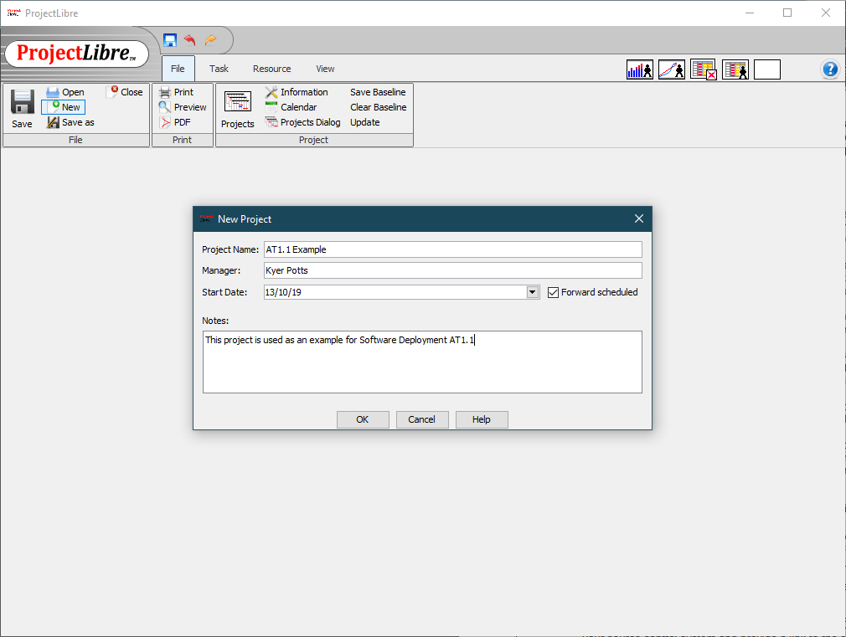

##### Adding a Task

To create a task, enter the name of the task, and the duration into the appropriate fields of the project. This will automatically fill out the start and finish times of the task, and populate the task into the Gantt chart on the other window of the program.

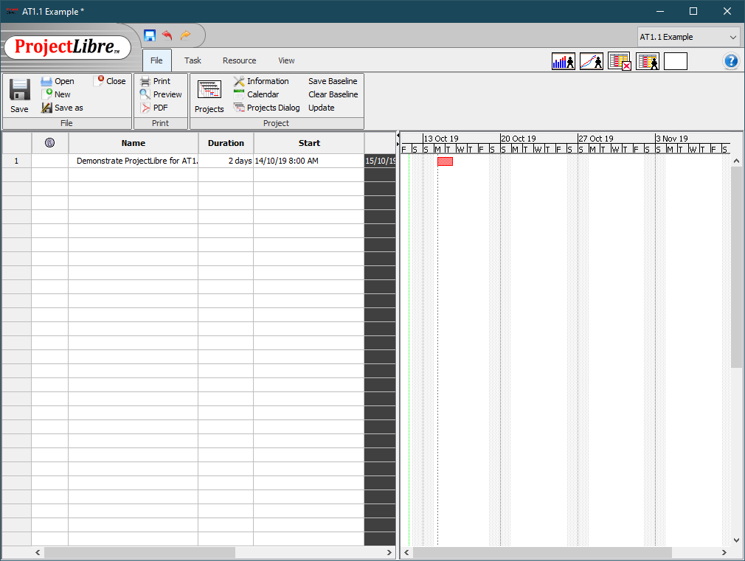

##### Connecting a Task

Tasks can be connected to each other with dependencies. This will automatically generate a dependency between tasks to highlight a critical path. To connect tasks, drag the parent task onto the dependant task.

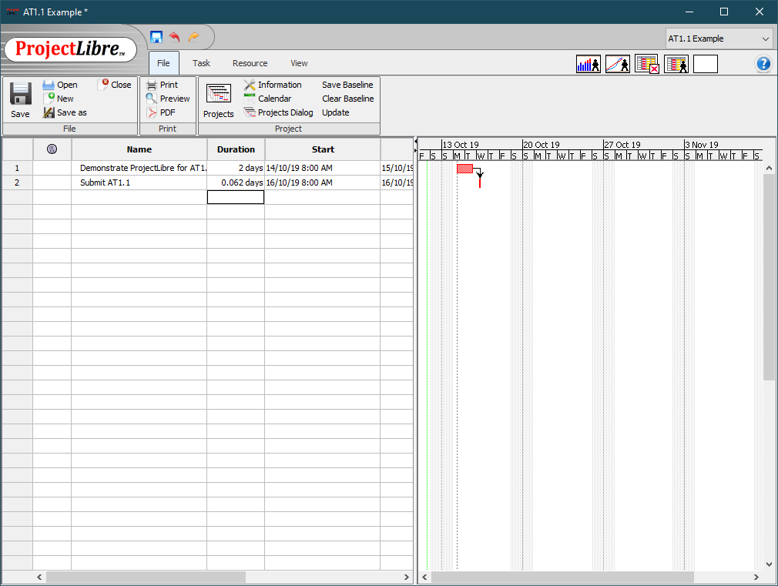

##### Saving the Project

To save the project, click the floppy disk save icon on the left-hand side of the control panel to open the save dialog box. Select the directory to save the file and click the save button to save the project.

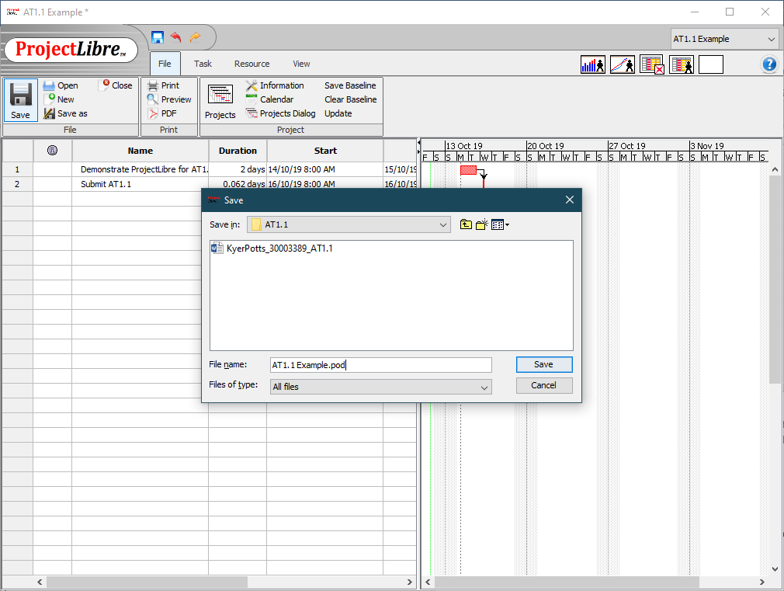

# Source Control System

### GitHub

GitHub is a Git repository service that allows users to upload code and facilitate open source collaboration. GitHub uses the version control software “Git” which was originally developed by Linux creator Linus Torvalds

### GitHub Features

##### Repositories

A repository is a container used to hold all the resources used within a single project. Repositories on GitHub have been designed to allow the upload of any file type associated with the creation and development of the project.

##### Branches

Branches create copies of the original master branch that was created to house the repository. Creating a branch takes a snapshot of the master branch and allows the user to experiment with changes or edits without affecting the master branch files.

##### Commits

Commits are saved changes made to the branch which the user is currently working on. When making commits on GitHub, a commit message is prompted so that the developer can explain the changes and why they have made them.

##### Pull requests

Pull requests are created to allow edits and changes of branches to be reviewed before being merged into a single unified branch. A pull request will show the differences between the two branches. These changes are shown in green and red for additions and subtractions to the branch the pull request was made to.

##### Merges

Merges are the final stage of alterations to a branch. By clicking the “Merge pull request” button on GitHub, the two branches are merged, and any changes made to the master branch via the branch copy are implemented. The branch copy can then be deleted or saved as a progress indicator or work marker.

# Collaboration Software

### Trello

Trello is a project management and collaboration tool that allows content collaborators to communicate and update stages or workflows within the project on a virtual whiteboard. This gives a visual overview to the project manager and allows them to effectively coordinate their team and allows shows the team a visual progress indicator of the project.

### Trello Features

##### Boards

A board represents a project beginning or currently under development, or a project that is consistently being worked on. Members of the collaborative team are added to the board, and permissions can be given to board members in order to correctly control the structure and layout of the project.

##### Lists

Lists divide the boards further into separate categories, usually representing a stage of progress. Lists organise cards within the board and allow more control over managing collaboration.

##### Cards

A card represents a specific element of a project. Cards can be assigned to any task that needs to be completed, from writing design documentation, to fixing a specific bug. Cards can then be further divided into checklist items, and comments can be added to the card by various members of the team to communicate important information concerning the task at hand. Cards can also be further customised by adding various functionality such as a due date, attachments, and can even be synchronised with GitHub repositories to seamlessly integrate changes in the development of a project.

# References

Anderson, K. (2019, September 4). *What is Rapid Application Development (RAD)?* Retrieved from Capterra: https://blog.capterra.com/what-is-rapid-application-development/

Finley, K. (2012, July 4). *What Exactly is GitHub Anyway?* Retrieved from TechCrunch: https://techcrunch.com/2012/07/14/what-exactly-is-github-anyway/

Fridman, A. (2016, May 6). *The Massive Downside of Agile Software Development*. Retrieved from inc.com: https://www.inc.com/adam-fridman/the-massive-downside-of-agile-software-development.html

Project-Management. (2016, September 15). *ProjectLibre Tutorial Part 1: Creating Your First Project*. Retrieved from Project Management Training: https://project-management.com/projectlibre-tutorial-part-1/

Tatvasoft. (2015, April 15). *Top 12 Software Development Methodologies & its Advantages/Disadvantages*. Retrieved from Tatvasoft: https://www.tatvasoft.com/blog/top-12-software-development-methodologies-and-its-advantages-disadvantages/

WPCURVE. (2015, January 21). *How we effectively use Trello for project management*. Retrieved from WPCURVE: https://wpcurve.com/trello-for-project-management/